Siamese Networks

A Siamese Neural Network (SNN) is a type of neural network architecture specifically designed to compare two inputs and determine their similarity. The network consists of two identical subnetworks that process the inputs independently but in parallel. The outputs of these subnetworks are then compared using a distance metric, allowing the network to learn whether the inputs are similar or dissimilar. SNNs are particularly useful in tasks where pairwise comparison is needed, such as in face recognition, signature verification, and one-shot learning.

Learning Pairwise Similaritiy Scores

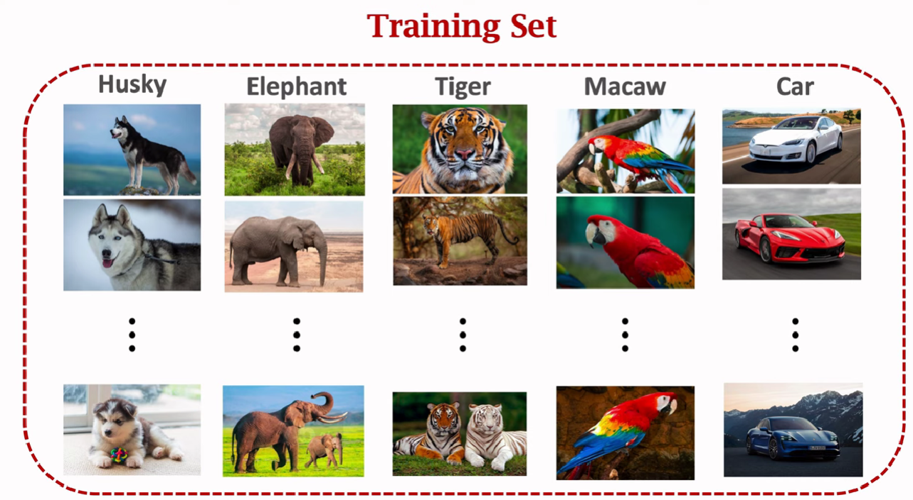

- Positive sample = sample that belongs to the target class.
- Negative sample = sample that does not belong to the target class.

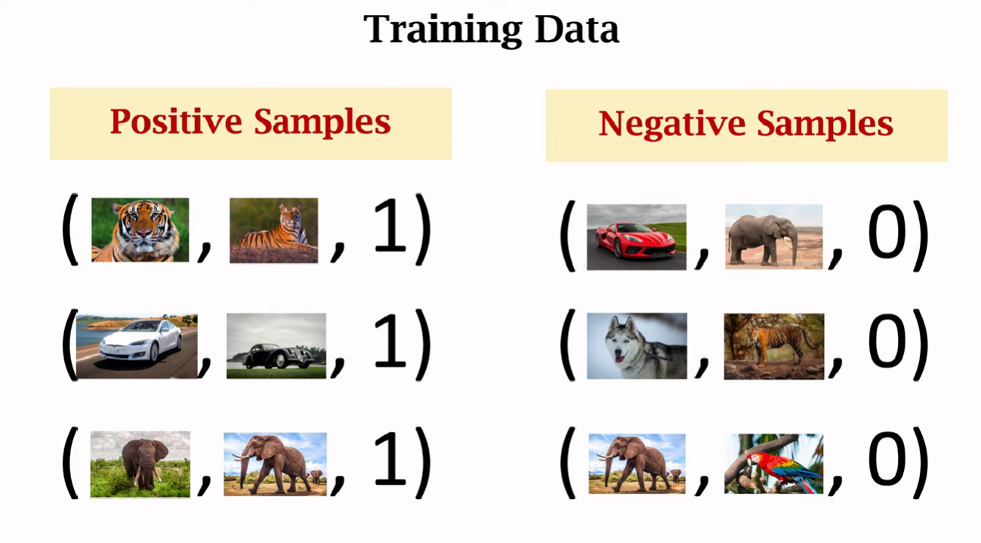

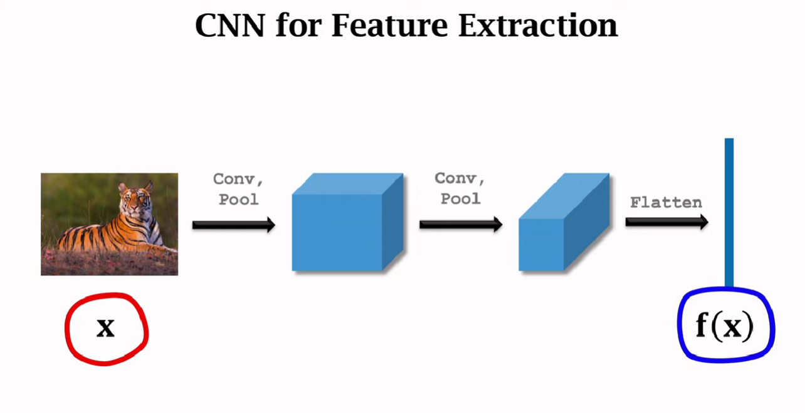

Positive Samples
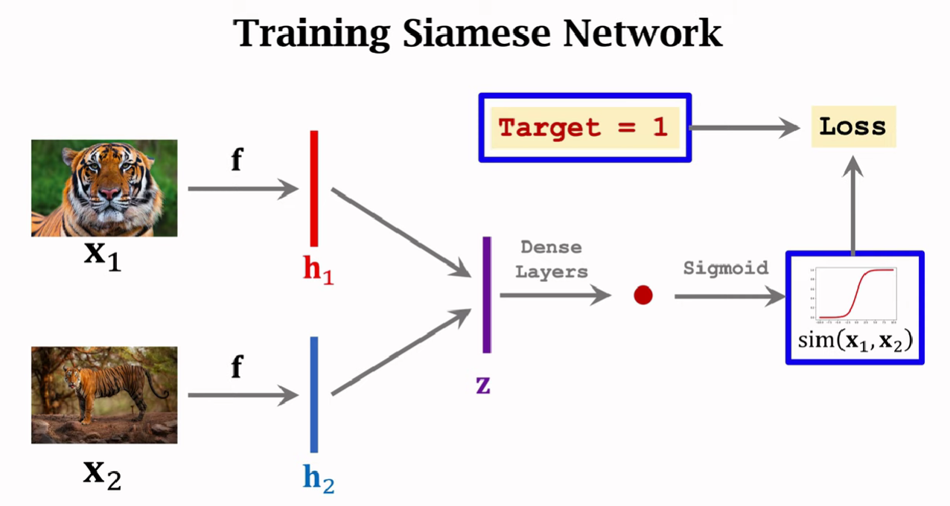
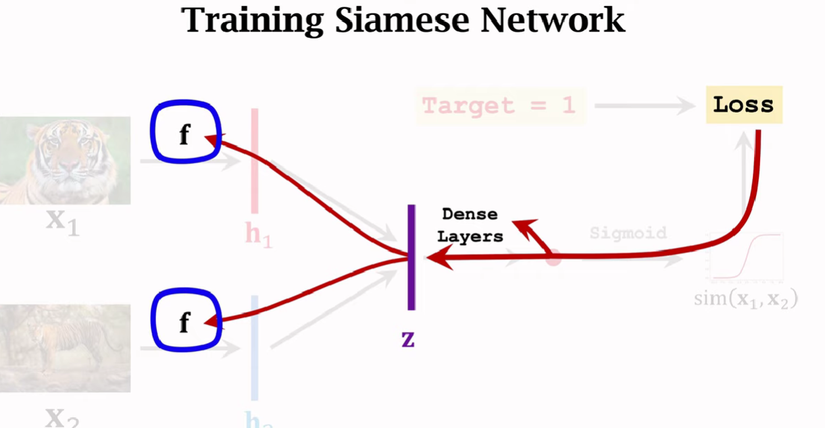

Negative Samples
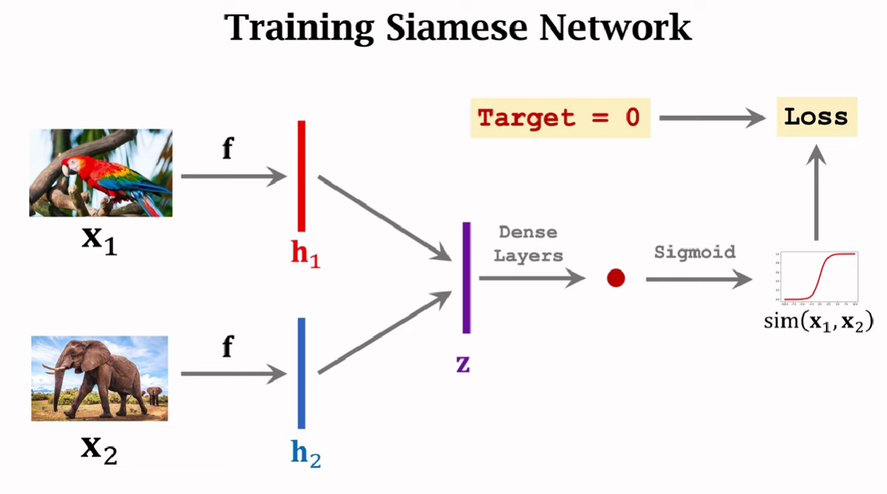

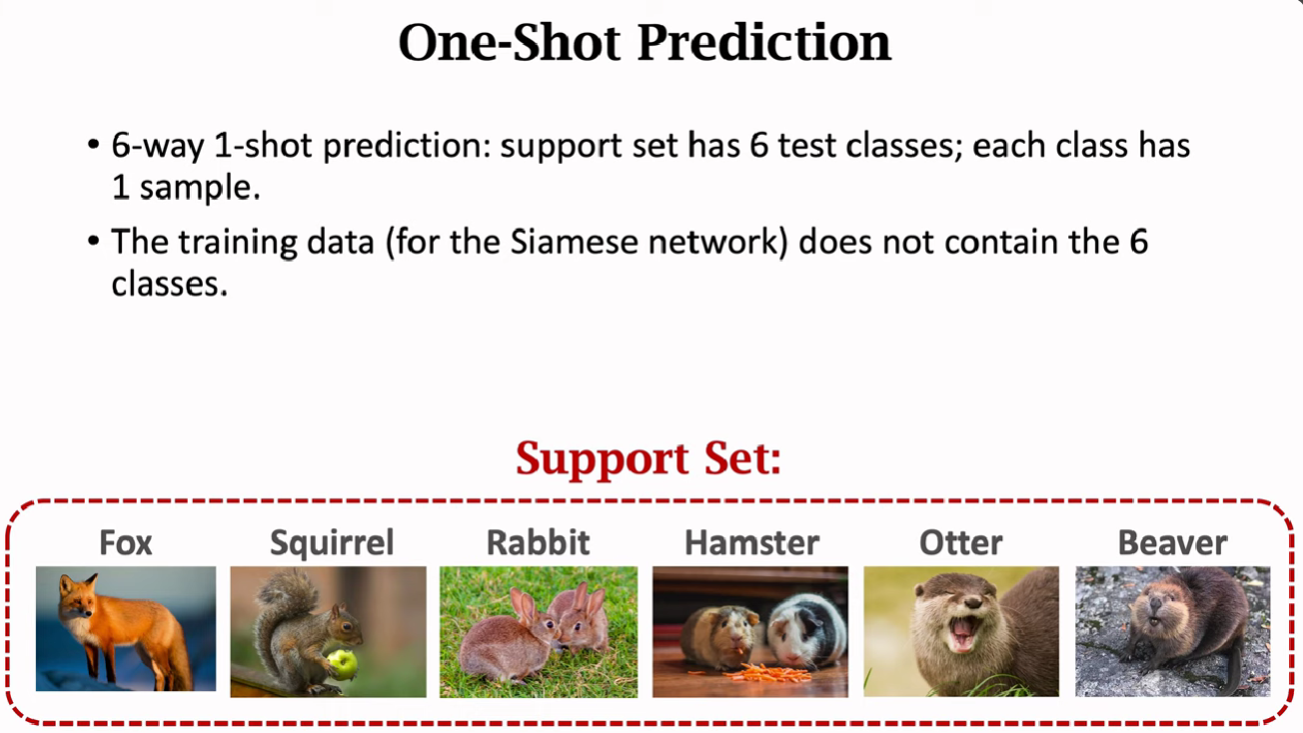
Learning Similarity
SNNs are designed to learn a similarity function that can distinguish between similar and dissimilar pairs. The network outputs a feature vector for each input, and the similarity between these vectors is calculated using a distance metric, such as Euclidean distance or cosine similarity. During training, the network adjusts its weights to minimize the distance for similar pairs and maximize the distance for dissimilar pairs.

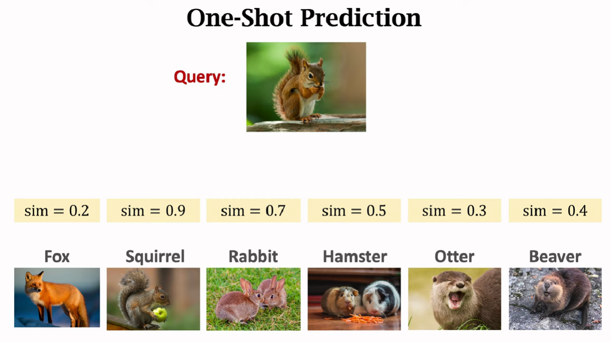

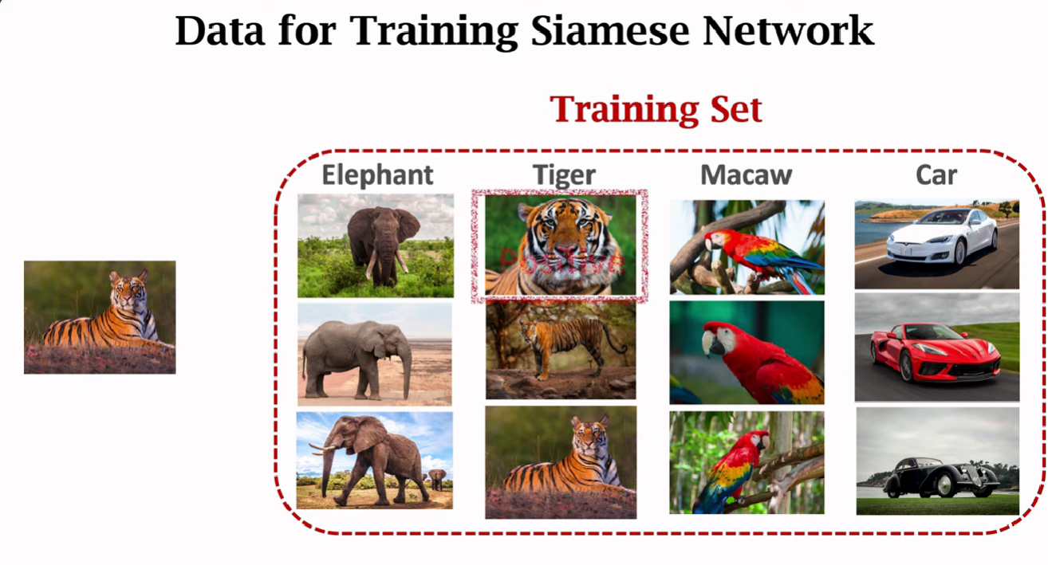
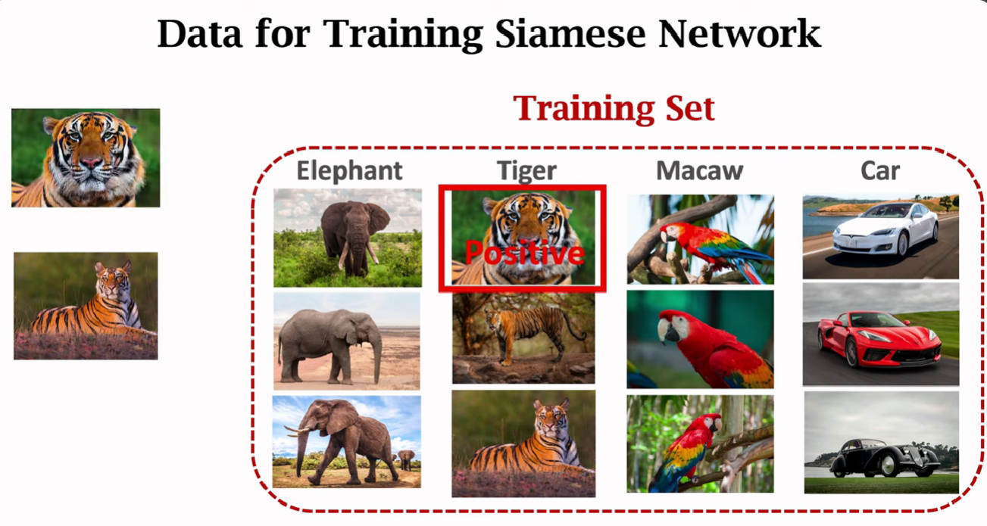
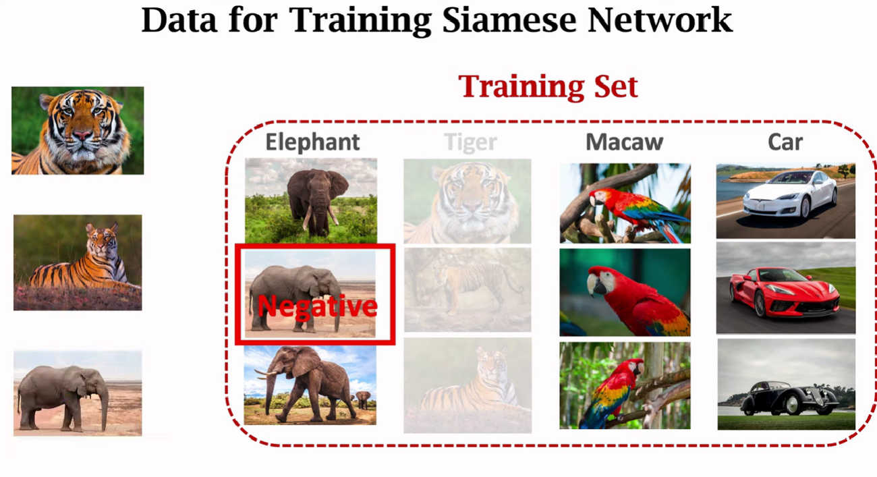

Triplet Loss


